**Explain the following questions in two simple sentences**

1. **What is the use of the git add command?**

Git add command is used to stage the changes from the working directory. We can review the differences in the stage before committing to the main repository.

1. **Write the command to create a branch “feature-group”.**

git branch feature-group

1. **What is a pull request? Write the steps involved in creating a pull request.**

Pull Request (PR) is used to merge changes in the codes/files from different branches to the main branch.

Steps:

i. Create a new Pull Request using Github Pull Request Tab

ii. Select the source branch(the branch we are trying to merge) and the target branch(usually main)

iii. Add title and description of the PR

iv. Click “Create Pull Request” button

v. Team members will review the code changes and approve

vi. Solve any merge conflicts

vii. Merge into target branch

1. **How do you add collaborators?**

i. Go to YourRepository > Settings > Collaborators > Add People

ii. Add the username or email of the person you want to invite

iii. Click “Add to repository”

iv. Wait for the person to accept the invite

1. **What is the command used to commit our changes in github repo?**

From working directory to stage: git add {fileName} / git add .

To commit: git commit -m "Commit message"

1. **Create a github account and repository to save all your assignment tasks. Example repository name: rg-assignments**

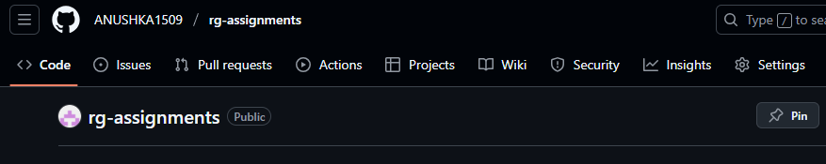

1. **Create a branch called feature-java(you can use it later to push all your java related tasks to this branch)**

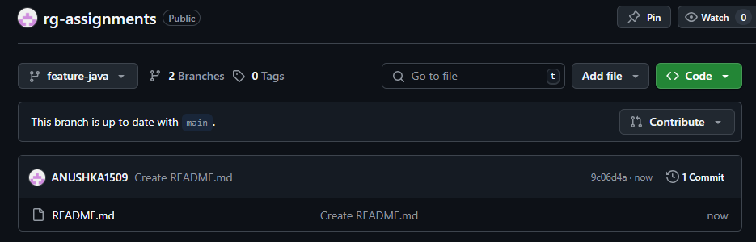

1. **Install IntelliJ IDE. Create a simple java project displaying “Hello World!!”and share the screenshot.**

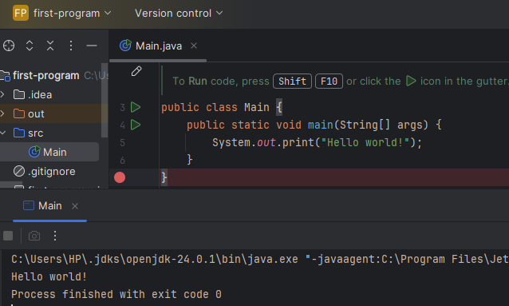

1. **In IntelliJ IDE, explore the shortcut keys for the following**
   1. **To run the project:** Shift + F10
   2. **To select a line:** Home → Shift + End
   3. **To comment/uncomment a line:** Ctrl + /
   4. **To delete a line:** Ctrl + Y